Bill # 73-40
The Graduate and Professional Student Association (GPSA)
The Pennsylvania State University

of the 73rd Assembly
March 20, 2024

Be it decided by the Assembly of Elected Delegates,

Colombian Graduate Student Community at Pen State (CGSC) Co-Sponsorship
Funding for Colombian Scientific Diaspora Symposium
(Decided: [ Y])

Nature of the Situation:

The Colombian Scientific Diaspora Symposium serves as a space to promote professional networks within the scientific diaspora of Colombians in the United States, fostering future collaborations within the Colombian research framework. Organized by the Colombian Graduate Student Community at Penn State (CGSC), the event will bring together colombian professors, researchers, and students in the United States to analyze and share knowledge on collaboratively addressing Colombia's research challenges.

Expected total attendance is 120 students with approximately 70 of those students being graduate/professional students.

The event will be held from May 5-6.

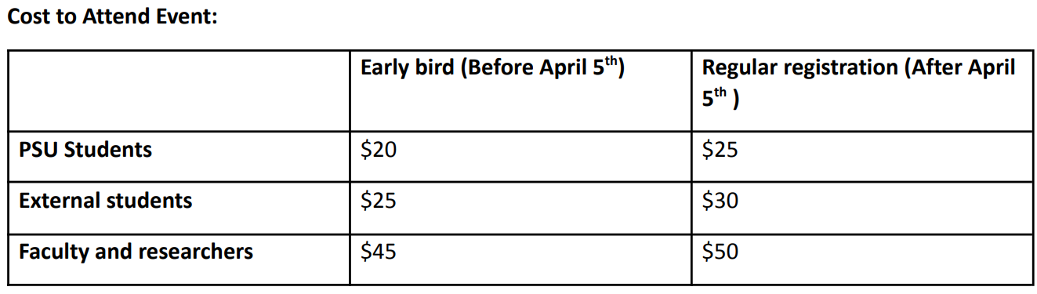

Recommended Course of Action:

The Graduate and Professional Student Association agrees to co-sponsor the Colombian Scientific Diaspora Symposium in the amount of $1500.

An itemized budget is below:

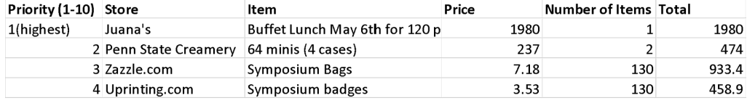

Total requested from GPSA: $3486.30
Total requested from UPAC: $20,000
Total requested from Penn State Global Strategic Partnerships: $800
Total from ticketing income: $1,670
Total cost of event: $26,316

Respectfully submitted,

Mary Ogidigben
Delegate, College of Engineering

President ___________________________________________________ Affirm Veto

The Graduate and Professional Student Association

