Bill # 73-38
The Graduate and Professional Student Association (GPSA)
The Pennsylvania State University

of the 73rd Assembly
March 20, 2024

Be it decided by the Assembly of Elected Delegates,

Asian Pacific American Law Student Association Co-Sponsorship
Funding for Holi
(Decided: [ Y ])

Nature of the Situation:

This is our Holi festival meant to celebrate the festival of colors and the significance of acceptance and forgiveness. With the coming of Spring, Holi is celebrated by putting various colors of power on friends, family members, and even strangers in the attempt of starting the new season with a fresh beginning of love as a united group.

Expected total attendance is 40 students with approximately 40 of those students being graduate/professional students.

The event will be held on March 26.

Recommended Course of Action:

The Graduate and Professional Student Association agrees to co-sponsor Holi in the amount of $350.

An itemized budget is below:
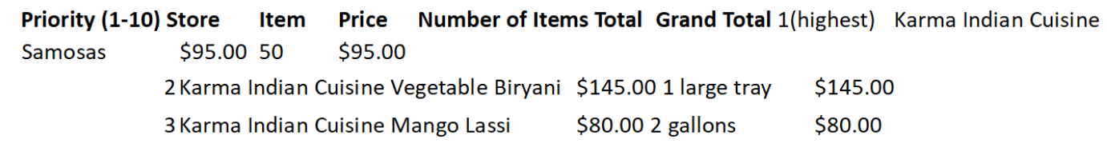

Total requested from GPSA: $350
Total requested from DEI: $35
Total cost of event: $350

Respectfully submitted,

Mary Ogidigben
Delegate, College of Engineering

President ___________________________________________________ Affirm Veto

The Graduate and Professional Student Association

