Bill # 73-34
The Graduate and Professional Student Association (GPSA)
The Pennsylvania State University

of the 73rd Assembly
March 20, 2024

Be it decided by the Assembly of Elected Delegates,

Student Association of Environmental Science and Engineering (SAESE) Co-Sponsorship
Funding for Penn State Interdisciplinary Environmental Research Symposium (PIERS)
(Decided: [ Y ])

Nature of the Situation:

The 26th annual Penn State Interdisciplinary Environmental Research Symposium, formerly the Environmental Chemistry and Microbiology Student Symposium (ECMSS), is a student-run symposium that includes student poster sessions, student oral presentations, and student lightning talks, as well as an Effective Science Communications workshop, and two keynote talks by scientists and engineers in environmentally relevant fields.

Expected total attendance is 100 students with approximately 40 of those students being graduate/professional students.

The event will be held from April 5-6.

Recommended Course of Action:

The Graduate and Professional Student Association agrees to co-sponsor the Penn State Interdisciplinary Environmental Research Symposium in the amount of $1000.

Total requested from GPSA: $4,255
Total cost of event: $11,256.58

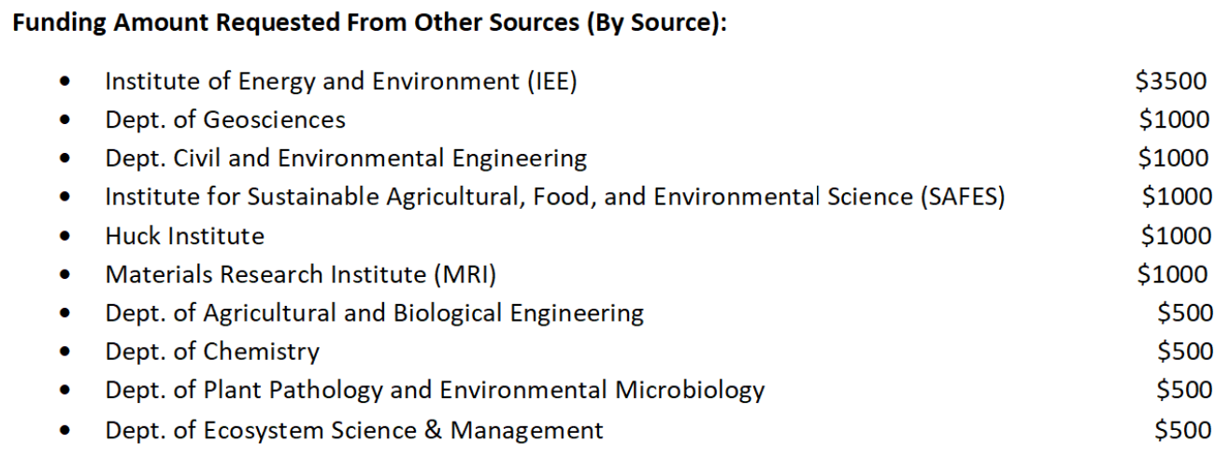

Respectfully submitted,

Mary Ogidigben
Delegate, College of Engineering

President ___________________________________________________ Affirm Veto

The Graduate and Professional Student Association

