Graduate and Professional Student Association

The Pennsylvania State University 315 HUB-Robeson Center University Park, PA 16802 Email: gpsaoffice@gmail.com

GPSA 70th Assembly Meeting | Wednesday, September 30, 2020 | 6:00 pm | Zoom meeting

Actions Items:
- Ama Agyapong and Maureen Kahiu confirmed as new At-Large Delegates
- Resolution 70-09 Constitutional Amendment (Membership Eligibility) discussed and will be voted on at the next Assembly meeting
- Make sure to attend committee meetings as well as Assembly – two unexcused committee absences are grounds for removal from the Assembly.
- Let Justin Korman of Professional Development know if there are any ideas for future ideas.

Legislation Passed:
- Bill 70-08 Virtual, At-Home Pottery-Painting Event Part 2

Agenda

- Meeting called to order: 6:03 PM
- Roll Call – See Appendix I
- Adoption of the Agenda
- Approval of Past Meeting Minutes from September 16, 2020: Approved
  - In the Appendices, the attendance/roll call will consist only of name and attendance status for readability purposes
- Open Student Forum: No comments
- Special Presentation: Anna Barone, Director, Student Care & Advocacy
  - Student Care & Advocacy an office that students often have to use if they’ve encountered something unexpected
  - Designed to provide support to students facing unexpected challenges so they don’t slip through the cracks.
    - Pandemic, racial crisis, and election all happening at once, creating a lot of problems for students
  - Aim to be students’ co-pilots and help guide them through crises
  - Student Care & Advocacy aims for equity
  - Often hard for students to ask for help, barriers include uncertainty about what one needs, finances, cultural differences, connectivity issues (Internet and access to care), and location.
  - Also barriers for people outside Student Care & Advocacy wanting to help others:
    - Don’t want to interfere
    - Don’t want to embarrass
    - Don’t want to make things worse
    - Don’t want to read it wrong
    - Don’t like confrontation
    - People not trained effectively to offer help
  - Located in the Boucke Building, but also responding to virtual inquiries
    - Drop-in Hours M-F, 10-12 PM
    - StudentCare@psu.edu
    - (814) 863-2020
    - Website: studentaffairs.psu.edu/studentcare
    - Mental Health Crisis Service Lines – text “LIONS” to 741741 or call 1-877-229-6400
  - Haven’t been heavily utilized, so encouraging people to reach out
    - Lots of people reaching out for themselves right now, but can report for friends, children, roommates, students, etc., as well.
  - Student Emergency Fund
    - 1500 students served since March - 30% international students and 17% grad students (60% of grad population helped was international)
    - Many admin have donated (and continue to donate) portions of their salary to the Student Emergency Fund.
  - Questions and Comments
    - Q: Is lack of funds a concern?
      - Yes, it’s a concern because it’s not an endowed fund; PSU is passing the hat and hoping for donations. It doesn’t feel like a secure source of funding.
    - Q: How does your office deal with the lack of mental health resources, especially for grad students?
      - A lot has changed this semester with CAPS, especially in relation to telehealth (can now counsel across state and international lines)
      - Center for Community Resources is a walk-in clinic available as a resource
      - Using the crisis line is a way to quickly get in touch with a counselor
    - Q: Hearing that insurance for telehealth is ending tomorrow, do you know anything about that?
      - News to Anna, but she will reach out to those in the know and get back to us.
      - Comment (Claire Kelling): Co-pays for telehealth services ending
    - Q: What is being done to spread the word about the Student Emergency Fund?
      - Advertised heavily initially in town halls and through word of mouth
      - Less than $30,000 in the Student Emergency Fund and the cap is a one-time grant of $1,000 to students who qualify
        - Have to be facing food and housing insecurity, which is hard to prove right now because of Lion’s Pantry and eviction moratorium
        - Also have to be a full-time student in good academic and financial standing
      - Criteria not fun to discuss and it’s not a perfect process
      - Not getting to every student who is actually in need because of criteria and barriers to asking for help.
    - Q: Are there plans to get a budget for the Student Emergency Fund through endowed funds or something?
      - Looking to learn from other campuses and universities about how to set up an endowed Student Emergency Fund
      - Pandemic slowed down progress, but also emphasized the need for this type of fund
- Executive Officer Reports
  - President – Alex Zhao
    - Thank you to everyone who helped out with the Town Hall on Monday
      - Good attendance and got a sense of the issues and concerns that are important to grad students.
      - If you were a moderator at the Town Hall and haven’t sent the Executive Board your notes yet, please do so ASAP.
      - GPSA will be answering all the questions posed at the Town Hall in a single document.
    - Bike Helmet Giveaway with UPUA
      - Got a lot of bike helmets into people’s hands
    - Meeting with Drs. Ades, Vasilatos-Younken, and Preston
      - Discussed resolutions passed
      - Talked about making travel funding info more accessible
      - Graduate research likely to continue even if the university moves online
      - Getting a visa remains difficult and the Grad School will share its plans for helping international grad students in the next few weeks
    - Attendance at committee meetings is important – two unexcused absences is grounds for removal from the Assembly
    - Questions and Comments
      - Q: Does the travel funding take registration fees for virtual conferences into account?
        - Funding opportunities vague and unclear and students are often redirected to their colleges or departments
        - Registration fees usually up to colleges and departments, but Alex will ask about this at the next meeting
      - Comment (Claire Kelling): Everyone has access to $500 worth of funding through UPAC (registration costs capped at $100), so take advantage of it and spread the word to constituents
  - Vice President – Julia Kelliher
    - Thank you to the Town Hall moderators for participating and helping foster conversation
    - President Barron said at the last Board of Trustees meeting that university unlikely to go fully online; PSU is getting pressure from state and federal levels to stay open
    - Logistical issues with updating the Dashboard more frequently; updated twice weekly because the info has to be entered by hand.
    - Waste water being tested, but no further info offered.
    - Asymptomatic random testing directing those with potential symptoms to symptomatic testing, which is skewing the data.
    - Questions and Comments
      - Alex Zhao: Walk-up testing now availabe to those working on campus
      - Q: So anyone positive for COVID-19 isn’t being included in the random testing stats?
        - If anyone is potentially symptomatic for COVID, they are redirected to symptomatic testing so they will theoretically get tested faster.
  - Treasurer – Matt Billups
    - Send invoices to him for bills and legislation
    - If committees have questions about funding, feel free to reach out to him
  - Secretary – Katie Warczak
    - Please let me know if mispronouncing delegates’ names or if delegates enter the meeting after attendance has been taken
    - Sending out the newsletter tomorrow, please submit any event announcements or graphics by 10 AM tomorrow morning
  - Faculty Senate – Star Sharp
    - Emergency Faculty Senate meeting yesterday that focused on faculty concerns about COVID issues and the increase in local cases.
      - Focused on concerns about continuing in-person classes
      - Concerns about people’s children’s inability to go to school as a result of the rising numbers
    - Committees formed to address these issues, though not everyone’s interests will be represented
    - Questions about faculty being treated fairly since some are being terminated with little notice
    - Barron suggesting that COVID numbers are being skewed because students are hoarding their test kits
    - No resolutions were passed
    - Unless PSU receives an order from the governor or other governmental authority, the university will not shut down
      - CDC has asked that if there’s a huge case increase, not to close and disperse students to other areas of the country
    - Questions and Comments
      - Q: Is the university concerned about dispersing students to other areas at Thanksgiving?
        - PSU has a lot of contingency ideas and acknowledged lack of control over students (especially off-campus ones), but no concrete plan.
        - Faculty Sentate concerned that by not passing resolution this week, the university will proceed without input from the Faculty Senate.
      - Q: How can the admin look at the numbers and deny that there isn’t an uptick?
        - Acknowledging lots of pressure from outside forces and need to try to contain things, even if they have limited control.
      - Q: What about when the Big 10 football games start?
        - There is no plan. PSU can’t control students or alumni, so this will likely be another problematic practice.
      - Q: What’s going to happen with Spring Break 2021?
        - Discussions about how to repay Labor Day efforts, but no concrete plans for Spring 2021.
        - University very dependent on federal regulations for guidance and policies, so hard to plan and proceed without guidance.
  - Graduate Council – Claire Kelling
    - Nothing to report, next meeting is in October
- New Delegate Confirmation
  - Ama Agyapong for At-Large Delegate
    - 4th year in Material Sciences and Engineering, president of Research Materials Society, and co-chair of EMS Student Council
    - Wants to be part of GPSA because can bring experiences to bear in a way that can assist all graduate students; there are limitations to what one can do at the departmental and college levels.
  - Questions and Comments
    - Q: What committee would you like to be in?
      - First choice is Advocacy, but also interested in Internal Development and Professional Development
    - Q: What do you see your role as an at-large delegate as?
      - Representing a wide range of graduate and professional students; it’s an opportunity to help more people and spread the word about the variety of resources and offices available to grad students.
      - As an at-large delegate, will reach out to and be present at different college and department events throughout the university. This is a little harder during a pandemic, but still important to be accessible to these students.
      - Very talkative, so open and willing to engage in discourse with others
    - Q: What will your leadership experience and EMS perspective bring to the table?
      - Learned to “shut up and listen” to constituents in order to hear and better represent them.
      - In EMS, have experience interacting with faculty and bringing students’ concerns to them so that changes can be made
      - People tend to be frank with Ama about the problems and difficulties they’re facing.
    - Q: How will you reach out to your constituents across the Grad School?
      - Get to know the systems already in place at PSU that gets a wide variety of grad students together, such as the Office of Graduate Educational Equity Programs, and go from there.
  - Maureen Kahiu for At-Large Delegate
    - Wants to become GPSA delegate because she admires what GPSA has done and wants to be part of it
    - Has experience working with administration and management systems
    - Want to improve GPSA’s communication with constituents
    - Less experience with racial diversity issues, but lots of experience dealing with gender, religion, and similar diversity issues
    - Questions and Comments
      - Q: What would you say about your Master’s status and your ability to serve as an at-large delegate?
        - Don’t have to be in a place long to have an effect
        - Don’t know a lot of student organizations right now, but can easily learn
      - Q: How can you advocate for underrepresented communities, especially low-income and first-generation students?
        - Lots needs to be done to connect these students to the correct offices, such as the one discussed at the start of the meeting (Student Care & Advocacy)
        - Having access to knowledge about resources will be advantageous because can then direct other students to these resources
      - Q: Besides getting students connected with offices, what are some big issues you see at Penn State for grad and professional students?
        - Relationship between grad students and professors; they sometimes have problems relating to graduation or being able to take personal time.
        - There are resources available to help students in these and other situations, but many don’t know these resources or even GPSA exists.
          - Can’t assume people are being communicated with via social media and email
        - Comment (Mandy Burton): Work-life balance is an important issue to you (and us), but there are barriers to helping students beyond connecting them to resources.
      - Q: Could you give a more concrete example of how to help graduate and professional students?
        - Perhaps passing a resolution or bill about working hours for graduate and professional students.
      - Q: What is your approach in reaching out to constituents outside your own college?
        - Work with other college delegates to get in touch with people as well as use contacts in student organizations.
      - Q: Do you know what committee you’d like to serve on?
        - Professional Development because she has previous experience working in this area.
        - Outreach would be second choice because she also has experience in this area.
  - Questions
    - Q: Alex, can you talk a little bit about the at-large delegate selection process?
      - Rolling application process, so still technically open
      - Application posted on social media, emailed to graduate student orgs, posted on Microsoft Teams, contacted people who had expressed interest in the past, and encouraged people generally to send it to those they thought would make a good delegate.
      - Three applicants including Ama and Maureen, but third applicant just interviewed on September 30th.
      - Will attempt to solicit further applications via social media, an email blast, and the newswire
      - One at-large position left if both Ama and Maureen confirmed
    - Q: What drew you (Alex) to each delegate?
      - Ama very dedicated to GPSA nomination, has good connections, and would be a strong delegate
      - Maureen’s previous work experience, role as treasurer in the Pan African Student Society, and work in Ag Sci are all beneficial and she has some concrete things that she wants to do.
  - Discussion
    - Mandy Burton: Worked with Maureen before and she’s quite keen to be involved and would be a good delegate.
    - Steven Baksa: Know Ama well and can vouch for her as an excellent delegate; when she says she cares, she really means it. I strongly recommend her as a delegate.
    - Kade Crittenden:
      - Ama is a great people person, talked to her quite a bit in the breakout room during the previous meeting and she followed up with Kade after the meeting as well.
      - Master’s students make up about half of the graduate student population and it would be great to have Maureen as a delegate.
NEW DELEGATES CONFIRMED 32-0-1 (See Appendix II)
- Graduate Council Alternate Nomination
  - We need to nominate alternates in case Grad Council delegates can’t attend, so nominating Lauren Katch as third Grad Council alternate
    - Appointed as College of Engineering delegate, but wants to further involvement with GPSA and become more acquainted with the workings of the Graduate School.
    - Experience as an undergraduate and having conversations and networking outside of Engineering.
  - Questions
    - Q: Are you generally available from 3-5 PM on Wednesdays?
      - No, she has a lab on that day
NOMINATION WITHDRAWN
- Resolution 70-09 – Constitutional Amendment (Membership Eligibility)
  - GPSA never represented Dickinson School of Law students and they recently overwhelmingly voted to not be represented by GPSA, so this amendment clarifies that GPSA does not represent Dickinson students.
  - Does specify that GPSA represents IUG students when enrolled in one or more graduate credits.
  - Questions and Comments
    - Comment (Claire Kelling): Important legislation for us in relation to IUG students
    - Motion to remove the first instance of “enrolled” in Section A; seconded
    - Want to make it clear that GPSA represents IUG students because there have been questions about IUG participation in GPSA in the past.
    - Comment (Steven Baksa): This legislation has to pass through two meetings, so a vote in favor tonight doesn’t make this part of the constitution yet.
  - Motion to table vote until next meeting; seconded.
- Bill 70-08: Virtual, At-Home Pottery-Painting Event, Part 2
  - Programming Committee wanted to amend pottery event for next two months
  - Mostly the same, but with a few changes
    - Adding a student eligibility question at the beginning of the Google Form
    - To safeguard the promo code, the list of approved participants will be sent to 2000 Degrees
      - Not in the previous bill, but did it for the first event and it worked out well.
    - Requesting to increase participant number to 70 given the amount of interest
  - Questions
    - Q: Is there a Zoom component of this event?
      - Yes, students get the pottery from 2000 Degrees and on a particular evening, people can convene on Zoom to paint together.
    - Q: Can we make it so that people can’t participate in this event twice?
      - We could, but haven’t thought of that yet because we prioritize people who are waitlisted or haven’t participated yet. Could make that provision specific though.
      - Could restrict the Google Form so the same email address couldn’t be used to sign up twice.
    - Q: Are we going to have 140 people each month?
      - No, 140 for the next two months, so 70 participants in October and November
    - Q: The language of the bill doesn’t require us to pay 2000 Degrees if we don’t reach 70 participants, right?
      - 2000 Degrees only bills GPSA for actual participants
  - Discussion
    - Alex Zhao: Don’t have to retroactively change legislation; the last bill funded 90 participants, so there should be 15 vouchers still left over and the bill can ask for the difference.
      - Should make a motion to strike the mention of past legislation in the current bill.
    - Lan-Nhi Phung: Wrote current bill to replace the one proposed, so this is an additional 80 vouchers on top of what has already been funded
    - Language in last paragraph changed to clarify the number of kits being purchased (80 additional kits for a grand total of 170 kits)
    - Language changed to formalize the prioritization of waitlisted participants as well as to specify that people may only participate once.
    - Star Sharp suggests that there should be a specification that participants are determined on a first come, first serve basis, but this is not put into the bill.
BILL PASSES 35-0-0 (See Appendix II)
- Reports
  - Speaker of the Assembly – Yasha Duggal
    - Welcome and congratulations to the new delegates
    - Need to attend committee meetings – two absences makes you eligible to be removed from the Assembly..
      - All committees are important, so make sure you’re attending and advocating
    - Make sure you fill out the Google Form about absences and proxies by noon on the day of Assembly meetings
      - Please try to find proxies for Assembly meetings
    - Comment (Star Sharp): Faculty Senate has the same rule – can’t be in Senate unless on a committee and participating in it.
  - Advocacy and Diversity – Diego Hernandez (provided by Claire Kelling)
    - In the process of planning a recap of the Town Hall and possibly inviting some offices to discuss resources.
    - Racial justice resolution planned for the next Assembly
  - Professional Development – Justin Korman
    - First Professional Development event today; Office of Career Services talked about pandemic struggles and career transitions
      - Had about 15 attendees
    - Planning Writing Bootcamp
    - Open to suggestions for future events
  - Programming - Jocelyn Delgado
    - Grad Cup sign-ups open until October 4th – already have 80 participants
    - Next meeting is Monday at 11 AM
  - Community Outreach – Katy Gerace
    - Arboretum event – 1 spot open for Saturday and 2 open for Sunday
      - Already planned and advertised
  - Internal Development – Steven Baksa
    - Constitutional amendment discussed today will be voted on at the next Assembly meeting
    - Next committee meeting on Thursday from 6-7 PM – will be talking more about first-semester newsletter and IGP
- Liasion Reports
- Judiciary – The Honorable Michelle Massey (provided by Emily Lesher)
  - No updates
- Student Truestee – Bryan Culler
- Advisor – Adam Christensen
  - Nothing to report
- Comments for the Good of the Order
- Meeting adjourend at 8:25 PM

Appendix I

U= Unexcused Absence E= Excused Absence P= Present L= Late

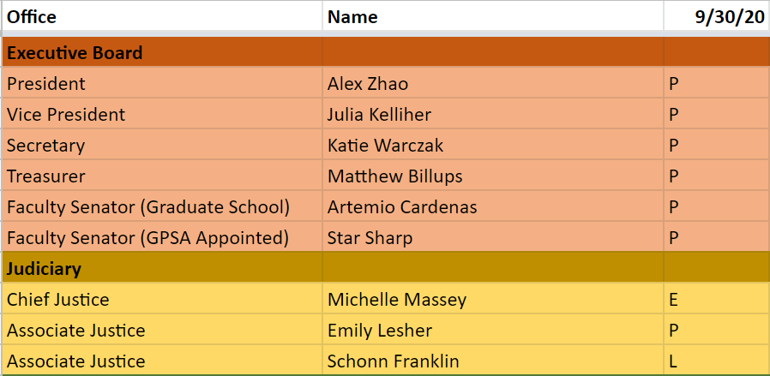
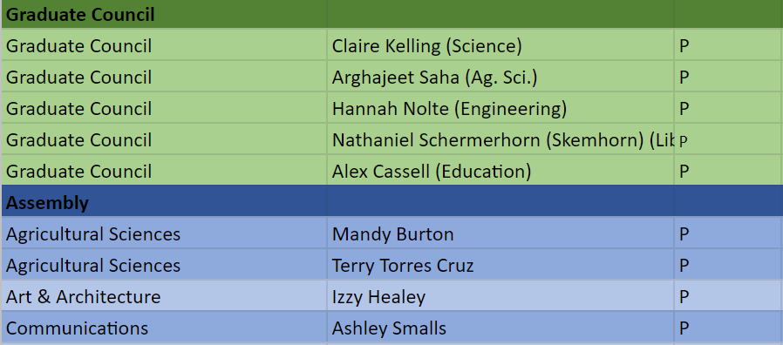
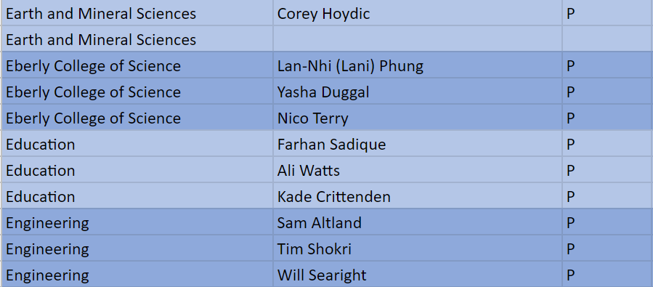
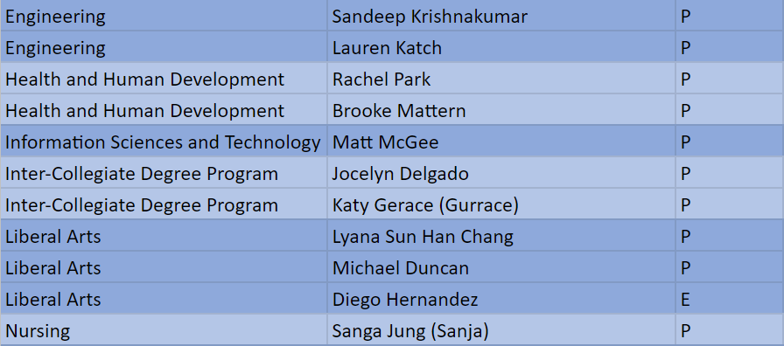
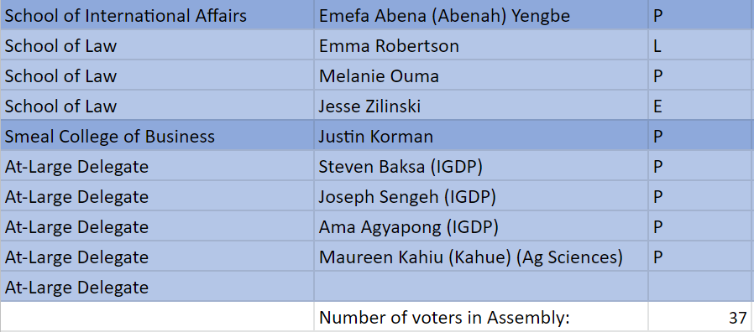

Appendix II
U= Unexpected Absence E= Excused Absence A= Abstain Y=Yes N= No

