Graduate and Professional Student Association

The Pennsylvania State University 315 HUB-Robeson Center University Park, PA 16802 Email: gpsaoffice@gmail.com

GPSA 70th Assembly Meeting | Wednesday, September 16, 2020 | 6:00 pm | Zoom meeting

Actions Items:
- Confirming New Delegate
- Let Alex know if you are interested in being a poll worker at the Bryce Jordan Center or the HUB during the upcoming election
- Let Alex know if there are any issues he should bring up in a student leaders meeting on September 18th
- Let Alex know if there are any issues that need to be brought up in the September 23rd meeting with Dr. Ades and Dr. Vasilatos-Younken
- Sign up to be a GPSA Town Hall moderator on Slack
- Let Mandy Burton know if there are any issues the Libraries Advisory Committee should address

Legislation Passed:
- Resolution 70-06 Bylaws Amendment (Clarification of Committees and Legislative Roles)
- Resolution 70-07 Bylaws Amendment (Change of At-Large Delegate Role)
- Resolution 70-08 University Response to COVID-19: GPSA Concerns and Recommendations
- Bill 70-07 Virtual, At-Home Pottery-Painting Event

Agenda

- Meeting called to order: 6:01 PM
- Roll Call – See Appendix I
- Adoption of the Agenda
  - Motion to move “New Delegate Confirmation” until after Resolutions 70-06 and 70-07 – Approved
  - Motion to change “Meeting Minutes from 4/29/2020” to “Meeting Minutes from 9/2/2020” - Approved
- Approval of Past Meeting Minutesfrom September 2, 2020: Approved
- Open Student Forum: No comments
- Special Presentation: Sarah Ades, Associate Dean, The Graduate School
  - Dr. Ades assists with graduate issues (she is an ombudsperson) and went over the current conflict resolution pathway and the new ombudsperson policy that’s being worked on.
  - New ombudsperson program would involve ombudspeople outside of programs and the Graduate School. The new program is currently working its way through the Graduate Council, but hoping that it will pass in October.
    - Ombudsperson program worked its way through GPSA last year
  - Working to launch several major programming efforts over the next few years for graduate students
    - Partnership with Career Services and Schreyer Institute for Teaching Excellence
    - Career Development – Accelerate to Industry Program
    - Professional Development – Expanded teaching development programming
    - Dr. Ades is herself working on programs relating to mentoring, especially mentoring programs for graduate advisors and faculty.
      - Would also like to help train graduate students to be mentees
    - Academic integirty policies for graduate education
    - Graduate student leave policies
  - Questions and Comments
    - Q: How are these programs being advertised?
      - Advertised through social media and similar avenues, though Dr. Ades welcomes suggestions as to how to advertise to grad students effectively.
    - Q: How can grad students be helped in relation to formatting their resumes and CVs for different industries?
      - Platform called LionLink that allows for mentoring; usually for undergraduates, but also for graduate students
    - Q: What is the grad school doing to combat systemic racism at the University?
      - Important to incorporate DEI into everything; provided an example of inclusiveness in the teaching initiative
    - Q: Are you aware of current programs that can help grad students become better mentors or mentees?
      - Some done through individual departments, but Dr. Ades said that if people are interested, she could look into a “Best Mentee Practices” workshop through the Schreyer Institute for Teaching Excellence.
      - NIH opening up some of their seminar series for all grad students
    - Q: What is Penn State’s response to the lack of African American faculty at the University?
      - Graduate School doesn’t hire faculty, but tries to encourage diversity in hiring and admission of graduate students (next generation of faculty)
      - No action items, but Dr. Ades wants to see a push toward more holistic admissions
    - Dr. Ades asks to be reminded of what she said she would forward.
- Executive Officer Reports
  - President – Alex Zhao
    - Introduced Natalie DeSouza, GPSA’s Communications Intern
      - Happy to spread messages and create graphics about events
    - Committee attendance is required just as Assembly attendance is required
      - Committee chairs should send attendance sheets to Katie Warczak
    - After the meeting, Alex will be sending out an email template on Slack so delegates can introduce themselves to the deans of their colleges
    - Make sure you’re available for the September 28, 2020, Town Hall
    - Have a meeting with Dr. Ades and Dr. Vasilatos-Younken on September 23rd – let him know if there are any items that he should bring up in the meeting
      - Current topics for the meeting
        - Follow-up on the international graduate student situation
        - Highlighting the resolutions that GPSA has passed
        - Issue of Student Engagement Network grants not being available to graduate students
    - On Friday, student government leaders will be meeting with PSU admin, so let him know if there are any items you want addressed
    - COVID-19 Testing
      - Suspected close contact testing is 10 AM-5 PM every day in the HUB parking deck – no appointment necessary
      - Symptomatic testing is available in the Eisenhower parking lot – need to have symptoms and an appointment through UHS symptoms
    - PSU Votes Meeting
      - Newsletter will include information on how to become a poll worker
  - Vice President – Julia Kelliher
    - Please add your pronouns to your names on Zoom
    - GPSA Virtual Town Hall on Monday, September 28, 2020, from 6-8 PM
      - Designed to help us hear from constituents
      - Event will consist of a brief presentation from Alex and then breakout rooms with a GPSA moderator
      - Will need moderators – sign-up sheet to be posted on Slack
        - Delegates are expected to attend the Town Hall
      - Please help advertise that the Town Hall is being hosted
  - Treasurer – Matt Billups
    - Have renewed our membership in the National Association for Graduate and Professional Students – non-legislation expense
    - Had a Lyft assistance program that has $1300 left on it, so can decide to continue the project or spend the money elsewhere
  - Secretary – Katie Warczak
    - Please let me know if mispronouncing delegates’ names or if delegates enter the meeting after attendance has been taken
    - Sending out the newsletter tomorrow, please submit any event announcements or graphics by 10 AM tomorrow morning
  - Faculty Senate – Star Sharp
    - First Faculty Senate meeting of the year yesterday – lasted from 1-5:30 PM; many feelings and reactions to the University’s COVID-19 policies and the lack of inclusion of the Faculty Senate in those decisions
      - Faculty Senate President consulted, but not Faculty Senate itself since it doesn’t meet over the summer
    - Sustainability Resolution passed, so a task force will be created
    - Much of the work yesterday was related to COVID-19 and people expressing their displeasure.
  - Graduate Council – Claire Kelling
    - First Grad Council meeting today
      - Ombudsperson program will be voted on in October
      - Starfish will be rolled out for graduate students in addition to undergrads starting next week.
    - Opening Grad Council meetings to the public
      - Grad Student Caucus in favor of having the meetings be public, same with Faculty Senate and Academic Affairs
      - Only Dr. Vasilatos-Younken was not in favor of having the meetings be public – worried that open discussion will be hindered by public status
      - Will have a vote on opening Grad Council Meetings in October
    - Considering paid family and vacation leave for grad students – will be discussed more in October as well
    - Questions and Comments
      - Q: What’s the difference between paid and unpaid leave?
        - Right now, vacation time is only federal holidays, spring break, and fall break, so the policy will outline policies in relation to this.
        - There will be reporting (possibly through new ombudsprogram) if advisors don’t comply.
- Resolution 70-06 - Bylaws Amendment (Clarification of Committees and Legislative Roles)
  - Clarifies the role of the President and Speaker of the Assembly in relation to appointing liasions and introducing legislation
  - Resolution focuses on clarifying different roles in the Assembly
  - Questions and Comments
  - Discussion
RESOLUTION PASSES 33-0-0 – see Appendix II
- Resolution 70-07 - Bylaws Amendment (Change of At-Large Delegate Role)
  - At-large delegates currently used to fill college-level seats in the Assembly if they become vacant, but the proposed resolution suggests these At-Large positions should be more focused on representing the entire graduate student body.
  - At-large delegates would still be appointed by the President with confirmation from the Assembly, but applications for the positions would be solicited
  - Questions and Comments
    - Q: Do the five at-large delegates have to be from the same constituency or different ones?
      - These delegates can be from any constituency
    - Q: In relation to Section J, to go from college delegate to at-large delegate, would they have to resign first?
      - College-level delegate could resign upon conditional appointment to an at-large position
  - Discussion
    - Diego Hernandez: There is a definite need to have a more in-depth vetting process for at-large delegates, so an application process and President collaboration with committees would be beneficial.
    - Claire Kelling: This legislation woudl require the President to work with committee chairs to develop the application.
RESOLUTION PASSES 34-0-0 – see Appendix II
- New Delegate Confirmation
  - Ama Agyapong (she/hers) nominated to be the Earth and Mineral Sciences delegate
    - Wants to represent the interests of underrepresented graduate assistants and encourage further diversity – interested in being part of the Advocacy & Diversity Committee
    - Wants to represent all graduate and professional students, not just those in her college
    - Leadership experience from military, undergraduate, and graduate activities she wants to bring to GPSA
    - Questions
      - Q: Are there any specific resolutions or pieces of legislation that you’d like to bring to the Advocacy and Diversity Committeee?
        - Would like to do more outreach with HBCUs and strengthen recruitment from these institutions
        - Ama herself came to Penn State through an SROP
      - Q: Could you explain an issue for EMS students that you’re interested in bringing to GPSA?
        - After an EMS survey, the results highlighted that EMS grad students felt lonely and isolated, largely due to a lack of diversity, so expanding that network to include different departments and base connections in love of research was recommended.
        - Would like to work more on preventing grad student isolation
  - Kade Crittenden (he/him) nominated to be a College of Education delegate
    - Studying higher education administration and interested in the Professional Development committee
    - Trying to become involved because of past experiences with student government
    - Wants to make sure the College of Education is well represented
    - Questions
      - Q: Could you speak to your role on the Code of Student Conduct?
        - There should be a report coming out soon and it’s provided a lot of insight into Penn State’s community and the presence of advocates within the administration.
        - Kade helped a lot with benchmarking Penn State’s code of conduct alongside other universities’ codes of conduct
        - Very interested in policy, so liked looking through the different codes and bringing back 5-6 recommendations from that research
        - Also did some research in relation to First Amendment rights and codes of student conduct
      - Q: How will you make sure your constituents are represented, especially those who are traditionally underrepresented?
        - Would reach out to administration in College of Education
        - Acknowledges doesn’t know all the issues facing graduate students so will keep learning
        - Will also reach out to underrepresented groups in College of Education
      - Q: How would you use your position of privilege to help combat systemic racism?
        - Would be able to start conversations with not only administrators, but also other cis, white males that can instigate change
        - Use platform of privilege to advocate for social justice – how he does this depends on context
        - Knows doesn’t fully speak for underrepresented groups, so would attempt to convey the thoughts and feelings of those groups as expressed to him.
  - Discussion
    - Q: What missing perspectives do these delegates represent?
      - Ama has a lot of connections within EMS and Kade has experience being a delegate at his undergraduate institution as well as dealing with racial bigotry.
    - Q: These two nominations would be college delegates, yes?
      - Yes.
    - Steven Baksa: Ama would make a great delegate, but her program (Material Science Engineering) doesn’t fall within EMS, she would be an IGDP delegate
      - Ama is ineligible to serve as an EMS delegate
    - Izzy Healey: Knows Kade a bit and can speak to his willingness to reach out and have conversations with people
    - Ali Watts: Pretty significant divide between Master’s and Ph.D. students in Education, so he would be able to bring a new perspective to GPSA from that angle
    - Diego Hernandez: Not sure Kade would be a good fit for this position given his answers to questions about graduate student issues.
    - Alex Zhao: Having Adam running a check on Ama’s eligibility; if she is ineligible, Alex would encourage her to apply for an At-Large delegate position.
    - Steven Baksa: Would support Ama being put forth as an At-Large delegate
    - Katy Gerace: Agrees Ama would be a great addition to GPSA
    - Mandy Burton: Could we table the delegate nominations?
    - Alex Zhao: Withdrawing Ama’s nomination since she is ineligible
    - Diego Hernandez: Kade didn’t really express how he would use his privilege for advocacy purposes, which leaves Diego with questions about his ability to serve, especially given his previous experience with these issues.
    - Emma Robertson: Echoing Diego’s concerns about Kade’s inability to fully represent his constituencies, especially underrepresented ones.
    - Claire Kelling: Making a motion to table nominations until better Education nominee can be found – seconded
      - Motion objected to and seconded
      - OBJECTION PASSES 10-24-1 – see Appendix II
KADE CRITTENDEN CONFIRMED 17-4-12 – see Appendix II
- Resolution 70-08 - University Response to COVID-19: GPSA Concerns and Recommendations
  - Concerns about Penn State’s plan for COVID-19, its effects on the local community, and how it benchmarks against similar institutions.
    - Some demands include:
      - Daily testing for all on-campus graduate and prfessional students
      - PSU Dashboard should be updated daily
      - University should outline specifically what would trigger a complete shift to online learning
      - Provide resources to assist in a sudden change to online instruction
      - Promote healthy Zoom use
      - Explicit and stringent penalties for students who don’t adhere to social distancing and mask wearing.
  - Questions and Comments
  - Discussion
    - Mandy Burton: Motion to make mention of New York Times piece and the re-implementation of Big 10 football in the resolution – movement approved
    - Yasha Duggal has suggestions from Nico Terry: minor linguistic changes on demands #1 and #3.
    - Steven Baksa: Wondering if demands could include free COVID-19 treatment for those graduate and professional students affected.
    - Sandeep Krishnakumar: Propose an additional demand that says the University should advocate for its international students to re-enter the country if travel restrictions are put into place.
    - Alex Zhao: Executive Board must send these resolutions to Damon Sims, Nick Jones, and Eric Barron – our previous resolution was not well received, but should the resolution pass, Alex plans to bring up this resolution and its demands in meetings with these individuals.
RESOLUTION PASSES 33-0-2 – see Appendix II
- Bill 70-07: Virtual, At-Home Pottery-Painting Event
  - Event is designed to provid a fun and socially distanced activity for graduate students – benefits to graduate students as well as a local business (2000 Degrees)
  - Graduate students can be engaged artistically and socially (Zoom painting nights)
  - Cost would be $1500 to provice 60 $25 vouchers for take-home pottery-painting kits; one painting night would be held each month for three months
  - Questions
    - Q: What is the average cost of a pottery activity – is this a medium-sized thing? A small thing?
      - The average cost was about $20, so $25 covers everything basic (could get two things that are $10 apiece)
    - Q: So do they have to order the kit and paint separately?
      - Participants can add whatever they want in the cart using the voucher and buy both pottery and paint simultaneously
    - Q: Has this event been advertised?
      - Event was mistakenly put on Instagram for 1-2 hours, so doubt that this was widely advertised.
  - Discussion
    - Yasha Duggal: Last year, people were satisfied with $20 limit, but would have been better to have a higher amount. The event was also very popular last year – sold out within a week or two with a waiting list.
    - Mandy Burton: Should we have more kits since this event sounds like it will be quite popular? Maybe change the number of kits from 20 to 25.
    - Melanie Ouma: Motions to move the number of kits up to 30 per month (total cost would be $2250) - Approved
BILL PASSES 36-0-0 – see Appendix II
- Reports
  - Speaker of the Assembly – Yasha Duggal
    - Committee meetings count toward attendance, so be sure to attend those
    - Use the template for bills and resolutions so edits can be done more easily
  - Advocacy and Diversity – Diego Hernandez
    - Had a good discussion about a resolution regarding social and racial justice – will be ready for the next Assembly
    - Possibly hosting a roundtable with organizations, offices, and groups dedicated to representing underrepresented graduate students after the Town Hall
    - Make sure all legislation abides by the advocacy and diversity by-laws
  - Professional Development – Justin Korman
    - First event scheduled – Career Services Rep will speak at next meeting about opportunities that graduate students have
    - Justin will send out more information later since it’s open to everyone in GPSA
  - Programming - Jocelyn Delgado
    - Meeting on Monday at 11 AM to discuss options for Grad Cup as well as the 2000 Degrees event
    - Continue promoting Grad Cup – have had quite a few people sign up already
    - Google Form has a lot of information about Grad Cup
  - Community Outreach – Katy Gerace
    - Recently set up a gardening event at the Arboretum – November 7th and 8th
      - Can accommodate 10 people each day
      - Still finalizing details, but will work on creating a flyer and sign-up form soon.
      - No weather contingency plan, but Arboretum hosts these volunteer events every weekend, so could probably reschedule if rained out.
    - Still looking into other events to be held outside
  - Internal Development – Steven Baksa
    - Lots of previous discussions involved the two pieces of legislation passed today
    - Meeting tomorrow from 6-7 PM to discuss a semester committee newsletter for GPSA and a collaboration with UPUA about IUG students and representation.
    - Let him know about any suggestions for changes to constitution or governing documents
- Liasion Reports
  - Faculty Senate Committee on Library, Information Systems, and Technology (LIST) - Matthew Billups
    - Looking at University-wide IT strategy to address Commonwealth and department challenges
    - Office of Information Security concerned about ransomware attacks, so stressed the use of OneDrive and SharePoint
    - Discussion about providing sufficient resources to faculty for remote instruction
      - Tech TAs might be an option to address some of the technology issues faculty are facing
  - Libraries Advisory Committee – Mandy Burton
    - Discussion of how libraries would function given another shutdown – emphasis is on HathiTrust
    - Let Mandy know if there are any issues we would like the Libraries Advisory Committee to address
      - Mandy will ask about library budget cuts (Farhan Sadique concerned about loss of three databases his college uses)
  - Faculty Senate Academic Equity Committee – Artemio Cardenas
    - Trustees attempting to implement institutional change – making the Board of Trustees “50% diverse”
      - This will be difficult given the current make-up of the Board of Trustees and how the Trustees are chosen
    - Community Survey results are now out, so should check that out
      - Graduate students had a 13% response rate, so there’s a desire to work more closely with graduate students on the next survey in about three years
      - Each college supposed to develop an action plan based on the results of the climate survey
      - GPSA could use the climate survey to drill down on specific graduate student issues in the next two to three years
    - Working on a Land Acknowledgement statement
- Judiciary – The Honorable Michelle Massey
  - Nothing to report
- Student Truestee – Bryan Culler
  - Second year as the Student Trustee (Board of Trustees)
  - On the Academic Affairs and Long-Range Planning Committees
  - As a result of the events of this summer related to race, finally convinced the Board of Trustees to create an Equity and Human Resources Committee
    - “50% diversity” includes a lot of factors, but the Board has settled on things like gender, including cisgender and transgender
    - 50% diversity to be achieved by 2025
  - Also working on Racism and Bias Task Force
  - Had to push back Board elections until November
  - Bryan Culler’s term will end in Spring 2021
  - Board of Trustees meeting this week
  - Questions and Comments
    - Q: Would the Board of Trustees consider a 50% male, 50% female Board of Trustees a success?
      - Technically, yes, but don’t think that’s the ultimate goal of the Board
      - Star Sharpe recommends defining the “diversity” parameters more clearly so don’t end up with an all-white Board of Trustees.
    - Q: Given how Board of Trustees elections function, how is diversity being encouraged from Governor-appointed and alumni members?
      - Board of Trustrees doesn’t want to unduly influence alumni elections, but encouraging Governor Wolf to nominate a more diverse slate of candidates
      - Alumni being encouraged to put forth diverse candidates as well even if Board of Trustees doesn’t have a direct say in the outcome.
- Advisor – Adam Christensen
  - Nothing to report, keep up the good work!
- Comments for the Good of the Order
  - Sandeep Krishnakumar: If we are going to ask nominees what specifically they want to work on in committees and what they would do in those committees, it would be good to tell them to come prepared for those statements.
  - Kade Crittenden: Thank you for all the comments today, excited to get to work!
  - Lan-Nhi Phung: It is important to advocate for diversity outside the Advocacy and Diversity Committee
- Meeting adjourend at 9:14 PM

Appendix I

U= Unexcused Absence E= Excused Absence P= Present L= Late
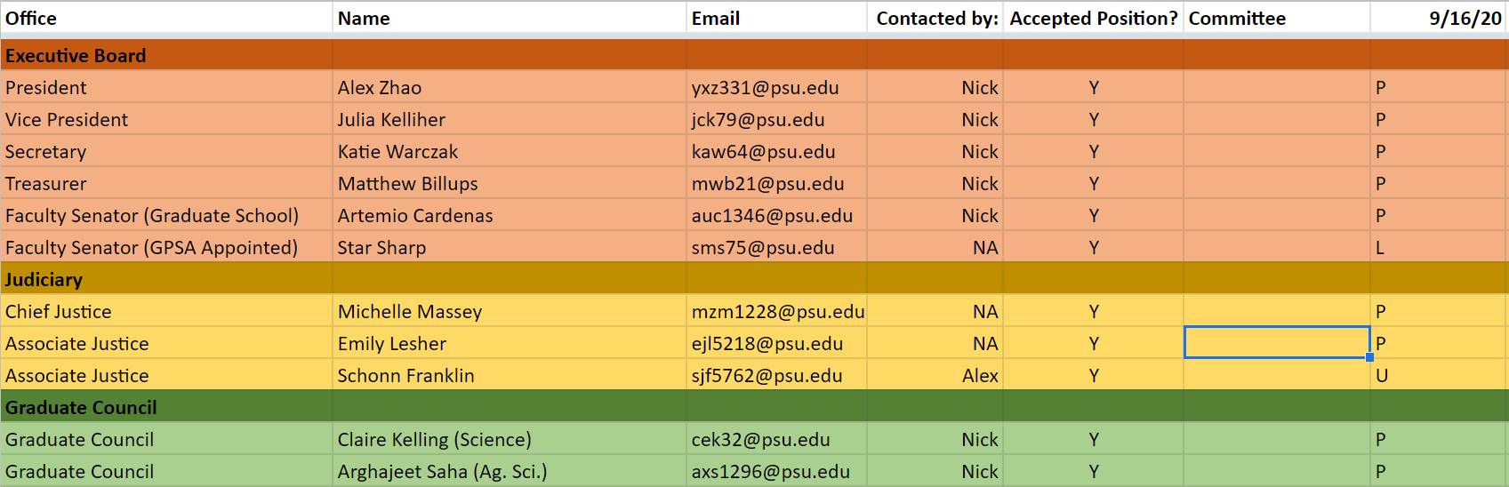
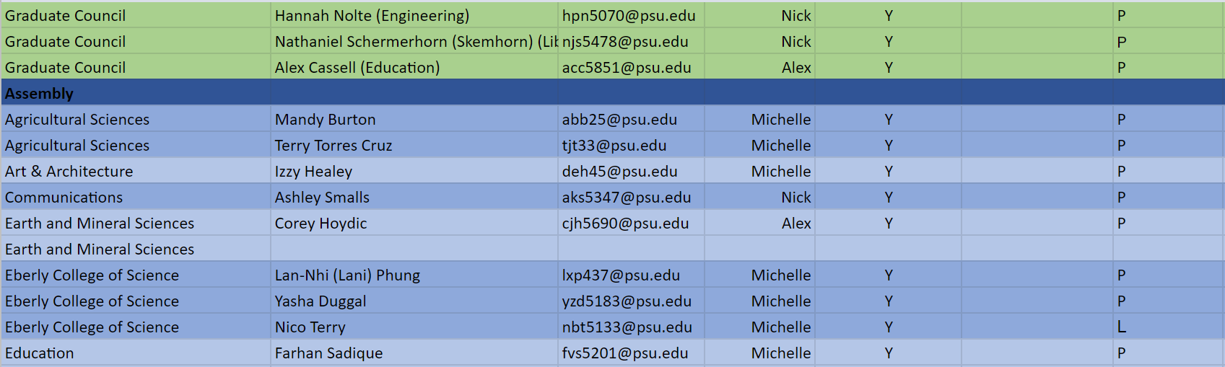
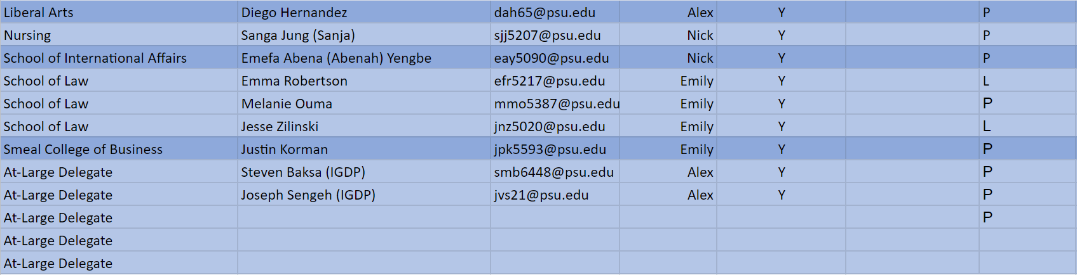
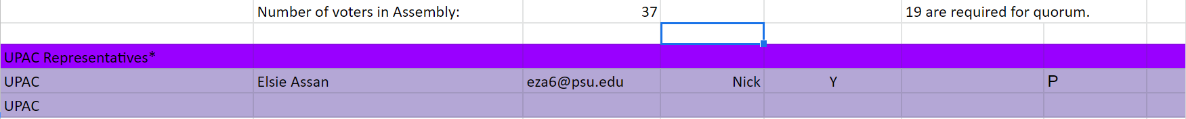

Appendix II
U= Unexpected Absence E= Excused Absence A= Abstain Y=Yes N= No
