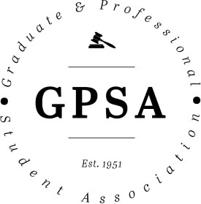
Graduate and Professional Student Association

The Pennsylvania State University 315 HUB-Robeson Center University Park, PA 16802 Email: gpsaoffice@gmail.com

GPSA 70th Assembly Meeting | Wednesday, April 29, 2020 | 6:00 pm | Zoom meeting

Actions Items:
- Confirming Presidential Appointments
- Let Alex Zhao know if you know of anyone interested in being on GPSA that could fill empty positions (Student Fee Board, Graduate Council, Graduate Council alternate, representatives from the College of Earth & Mineral Sciences, Education, Engineering, at-large positions, Grad Council ad hoc, and Student Insurance Advisory Board liasion)
- Election of the Speaker of the Assembly

Legislation Passed:
- Bill 70-01: GPSA Communications Intern
- Bill 70-02: Orientation Materials
- Bill 70-03: Welcome Back Picnic
- Bill 70-04: Writing Boot Camp

Agenda

- Meeting called to order: 6:02 PM
- Roll Call – See Appendix I
- Adoption of the Agenda
- Approval of Past Meeting Minutes from April 1, 2020: Approved
- Open Student Forum: No comments
- Special Presentation: Terry Torres Cruz, Outgoing Speaker of the Assembly
  - Discussed different GPSA assemblies members could be a part of
- Programming - Coordinates different events for grad and professional students - gala, welcome back picnic, Grad Cup, Theatre Days, happy hours, and other social events
- Community Outreach - strengthens relationship between grad students and community - lots of volunteering (Friday Lights Out - shutting off lights), donations for Centre Safe
- Internal Development - Policies and procedures in GPSA; Delegate Handbook; handle internal GPSA affairs and legislation.
- Advocacy & Diversity - Address student concerns and advocate for grad-related policies; Statement on Inclusion, which became part of constitution, GRE resolution, COVID-19 bills.
- Professional Development - Hosts programs and events related to job opportunities for students - Graduate Writing Boot Camp and Professional Head Shots
- Executive Office Reports
  - President – Alex Zaho
- Met with Dean Younken and Dr. Ades to discuss issues from the past academic year, including the recent town hall
- Trying to create a survey to see how grad students are being made aware of funding opportunities
- Still looking to fill a number of GPSA positions (Student Fee Board, Graduate Council, Graduate Council alternate, representatives from the College of Earth & Mineral Sciences, Education, Engineering, and at-large positions).
- Need liasion positions filled, especially for Grad Council ad hoc and Student Insurance Advisory Board (website lists liasion positions)
- There will be more transition meetings for the Executive Board in the next week, but after that GPSA won’t meet again until close to the start of the new school year
  - Vice President – Julia Kelliher
- Nothing to report, except excited to work with everyone
  - Treasurer – Matthew Billups
- Former treasurer Alex Zhao getting him up to speed
- Let him know if you need reimbursements
  - Secretary – Katie Warczak
- Let her know if mispronouncing your name or if you have a preferred name
  - Faculty Senate – Star Sharp
- Still in her position from the 69th Assembly; on the University Planning Committee
- Graduate Council met last week, mainly talked about undergraduate grades and admissions
- 3% cuts for entire university, so be ware of cuts in departments ad they may affect graduate assistants
- Many people getting furloughed and put on 50% benefits – primarily those who work at the BJC and Penn State hotels
- Complete the 2020 census and list State College as residence since that is where you would be if there were not a pandemic
- Two committees put forward proposals around sustainability that would try to get Penn State to get to net-zero emissions; need 1-2 people to serve on that committee.
- Every week, the information changes, but not a lot of movement on graduate issues
- Comment: Nico Terry interested in more info on the sustainability committee
  - Graduate Council – Claire Kelling
- Nothing to report since Grad Council hasn’t met since last month
- Outgoing Graduate Council representative, Alexander Wilson-Heid, will send a report out next week about what the next Grad Council meeting discusses.
- New Business
  - Confirmations of Presidential Appointments
- Star Sharp for Faculty Senate
- Diego Hernandez for College of Liberal Arts Delegate
- Corey Hoydic for Earth and Mineral Sciences Delegate
- Steven Baksa for At-Large Delegate
- Joseph Sengeh for At-Large Delegate
- Alexander Wilson-Heid and Katie Warczak for Graduate Council alternates
- All appointees approved by unanimous consent
  - Election of the Speaker of the Assembly
- Alex Zhao nominates Yasha Duggal
- Speaker approved by unanimous consent
  - Bill 70-01: GPSA Communications Intern
- Bill would provide funds for a communications intern for GPSA who would help do graphic design and manage social media. Some have also redesigned the website in the past
- Intern would be paid $15 per hour and work 6-15 hours per week
- Q: Intern works an average of 6 hours per week, right?
  - Yes

- Q: How do you plan on recruiting interns? What will the process look like?
  - Maddie (past intern) helped advertise it and we've had 3 interviews; will post a listing after this legislation is passed
  - Katie and Alex conduct interviews, hire someone by mid-May
- Comment: Interns have done really good work and the role is valuable; encourage to vote "yes" on this legislation – Claire Kelling
- LEGISLATION PASSES 30-0 (see Appendix II)
  - Bill 70-02: Orientation Materials
- Orientation materials (items, snacks and printed info about GPSA) need to be purchased and prepared over the summer
- Don't know whether in-person orientation will happen yet; money gets returned to us if we don't use it
- Better to discuss and pass legislation now as opposed to over the summer
- Q: Where is the $50 set up fee coming from?
  - Charged by vendor for setting up and providing items
- Proposal to add a line about distributing materials via other means if in-person orientation doesn't happen and GPSA has already purchased these items
  - "In the event that in-person orientations are not permitted and materials are already purchased, we will make other efforts to distribute these materials to graduate and professional students through their departments and organizations."
  - Added to lines 1-3 on page two.
- Amendment to the bill seconded and accepted
- Proposed that only items purchased are pens and bags since others tend to be thrown away
  - Agreement on this fairly consistent
- Q: Could we figure out how much of each product was used and cut back on materials accordingly?
  - Speaker puts everything in bags, so things are partitioned ahead of time
  - Gave away most bags last year (less than 200 left - no direct count taken though)
- Q: Terry Torres Cruz mentioned goods were left over from last year, are we rolling those over and factor in using old ones?
  - Only 20-50 bags, so would only supply one department (wouldn't factor into this calculation)
- Q: What are magnet clips?
  - Can clip things, but also a fridge magnet
- Q: Graduate enrollment likely to be lower next year, so we should factor that in?
  - The number of 1,000 was put forward after lower enrollment was discussed with Terry Torres Cruz
- Q: What are the products made of since we should be concerned with sustainability?
  - Most items are made of plastic
- Q: Is it possible to add things?
  - Yes, but have to make specific motions
  - Yes, but probably can't do that if we want to pass this legislation this assembly.
- Q: Can we switch out magnets for hand sanitizer?
  - $920 total for hand sanitizer, not clear if they have the supplies
- Durable goods can always be saved for subsequent years
- Motion to remove webcam covers and letter opener expenses (motion seconded and no objections)
- Objection to roll call vote (hand sanitizer rather than magnet clips?)- withdrawn call for vote
- Objection withdrawn and motion for roll call vote seconded with no objections
- New bill total: $5845.75
- LEGISLATION PASSES 27-1 (see Appendix II)
  - Bill 70-03: Welcome Back Picnic
- Picnic in the park; changed legislation so that the picnic can take place at any point during the fall semester
- If no Welcome Back Picnic, can host another event in Spring semester
- Since under $1500 can approve by unanimous consent rather than roll call vote.
- Q: What pizza vendor will be used?
  - Have used Papa John's in the past, could use Domino's - will be left to decide closer to the event date
- Q: Should we support local business to deliver the pizza?
  - Pizza Mia or Highway Pizza, perhaps; if they don't accept purchase orders, someone might have to put it on a credit card and be reimbursed
- Motion to specify that pizza will be ordered from a local vendor for this event - modification to line 2, page 2
  - "Pizza" to "Pizza from a local business within State College"
- Motion to recommend adding something about COVID-19 situation and an explicit back-up plan
- "In the event that the welcome back picnic cannot be held during the beginning of the semester due to ongoing circumstances related to COVID-19, the Programming Committee will try to organize an event to welcome students in person as soon as is feasible. In the meantime, GPSA will plan to host a virtual welcome event in this case" at the beginning of second page (lines 1-4).
- Comment: Nico Terry has suggestions for hosting synchronous events
- Motion to approve by unanimous consent
- APPROVED BY UNANIMOUS CONSENT
  - Bill 70-04: Writing Boot Camp
- Usually organized by Professional Development Committee
- 6 week sessions that provide grad and professional students space and food to do writing and research
- People have found it particularly helpful because it's an obligation to show up and work for 5 hours (also get free lunch)
- Legislation asks for funding for two six-week sessions, but not limiting it to Fall 2020 semester, so it can be put on in the Spring 2021 semester if need be.
- Total amount allocated is high, but amount might be lower if fewer people signed up for the boot camp.
- Q: Does Irving's has an undisclosed religious affiliation? People have expressed discomfort with them, so are we within the guidelines of the Statement of Inclusion?
  - Don't know
  - Owner's religious affiliation doesn't always translate to that of the business - gray area
  - No mention of religious affiliation on the website
- Motion to amend and be explicit about alternate options for Writing Boot Camp since there wasn't one this semester.
  - "In the event that the GWBC cannot be held during the Fall semester in person, the Professional Development Committee will plan to host a virtual event to support the writing of graduate and professional students during the Fall semester and the GWBC will be held at a later date." - Put under "Recommended Course of Action"
- LEGISLATION PASSES 28-0-1 (see Appendix II)
- Reports
  - Speaker of the Assembly – Yasha Duggal
- Nothing to report
  - Committees
- Advocacy & Diversity (Mandy Burton)
  - One piece of unfinished business - how Black and Latinx communities are being treated because of COVID-19; next chair will be asked to take this up and complete it.
- Professional Development
  - Nothing to report
- Programming
  - Nothing to report
- Community Outreach
  - Nothing to report
- Internal Development
  - Accomplished pretty much everything they wanted to the previous year; the main thing was implementing ranked-choice voting
  - Even with hiccups (see Judiciary Report), the ranked-choice voting was a success
  - Next Internal Development team should look at constitution and by-laws for things that seem out of place
  - Liaisons
- Alex Zhao – Device Policy
  - Penn State considering a device policy that would require students to have a certain type of device if admitted
  - Having a device policy would allow the cost of the device to be rolled into financial aid
  - Admin won’t start drafting anything until next calendar year (2021)
  - Q: What would happen for those who can't get the aid, but also can't afford the technology?
    - Not sure since only mentioned that PSU should have one
    - PSU might be able to offer devices at a discount
  - Q: Is this more beneficial for students or another barrier?
    - Some parts of the university have a device policy (College of Communications, for instance), so it makes sense for the university to have a baseline requirement
  - Judiciary Report – The Honorable Nick Dietrich
- Judiciary helps with rules questions, runs elections, and tries to make meetings run as smoothly as possible
- Feel free to ask judiciary for assistance during meetings if need be
- Congrats to new assembly
- Election Takeaways
  - Ran pretty smoothly; took slightly longer to tab results with ranked-choice voting
  - Issue related to IGDP seat, which there’s almost always an issue with (also the most competitive seat this year)
  - Encourages incoming Internal Development chair to think about what to do with IGDP
- Leaving in good hands with remaining judiciary members, but also need a new justice for next year
  - Student Trustee – Bryan Culler
- Nothing to report
  - Advisor – Adam Christensen
- Congrats to all new assembly members and Exec Board! This isn’t the best state of affairs as we've stepped into, but representation is needed right now and thank you for your service
- Stay engaged
- Here to advise and support you
- Comments for the Good of the Order – None
- Adjournment – 8:15 PM

Appendix I

U= Unexcused Absence E= Excused Absence P= Present L= Late

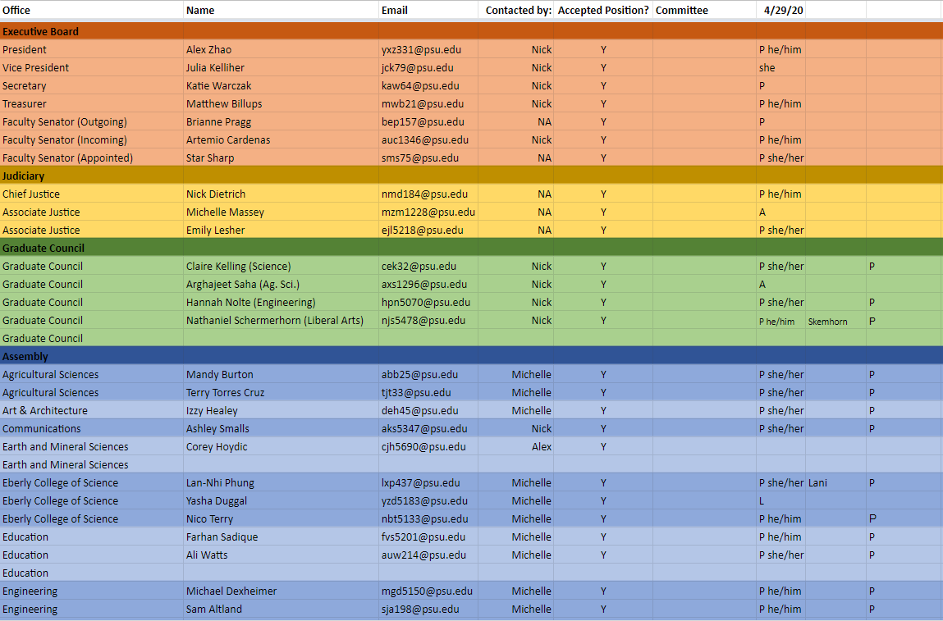
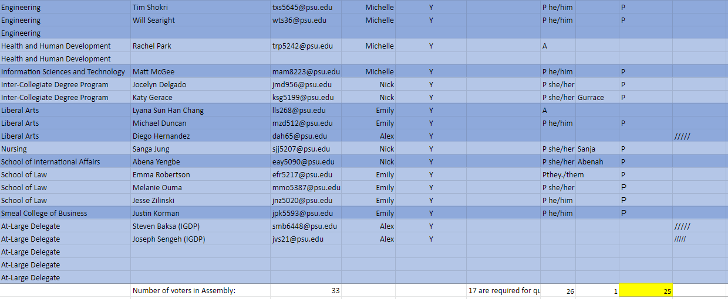

Appendix II

U= Unexpected Absence E= Excused Absence A= Abstain Y=Yes N= No
